DEPARTMENT OF PHYSICAL EDUCATION
SRIKRISHNA COLLEGE
Bagula,Nadia,West Bengal.

Post Event- Summary Report

Name of Event: | Annual sports 2019-20
Date of Event: | 06th March 2020.
Location of Event: | College ground
Number of Persons Attending: | Teacher- 85(including teaching & non teaching)
 | Students- 163
Objectives of the event: | Develop sports interest

The event was completed very successfully. More than 163 students were participated in different events and teaching and non- teaching staff were also participated in various recreation activities. On that day our respected President of our college and Principal were present in this ocassion and both were given a short speech regarding the benefits of sports and President declare open for the meet 2018-19. Total 16 events were organized in two groups such as Boys and Girls. In each group champion was declared based on points acquired. Rokeya Khatun was declared Girls individual champion and Bapi Sheikh was declared Boys individual champion respectively.‘Not win but take part’ that was the main motto of the event.
Summary

Pictures
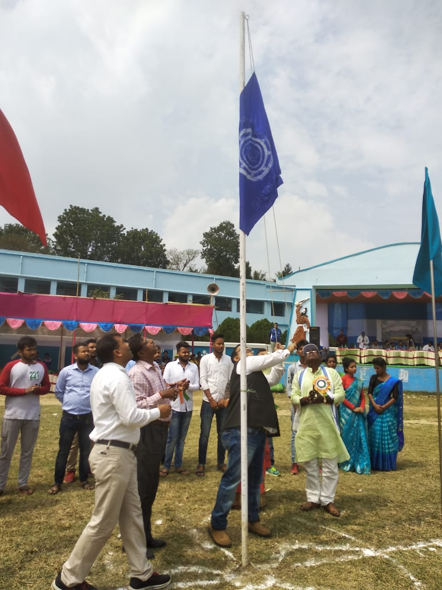 | 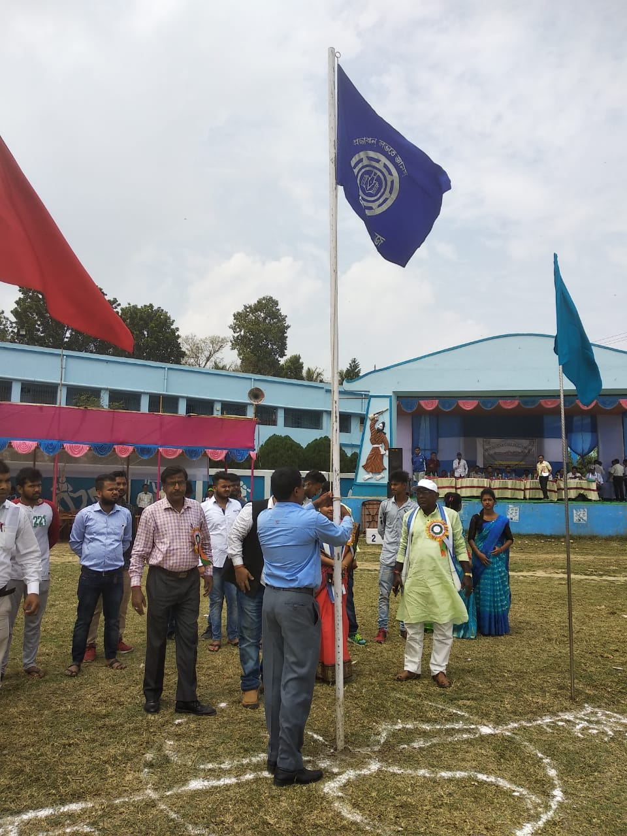
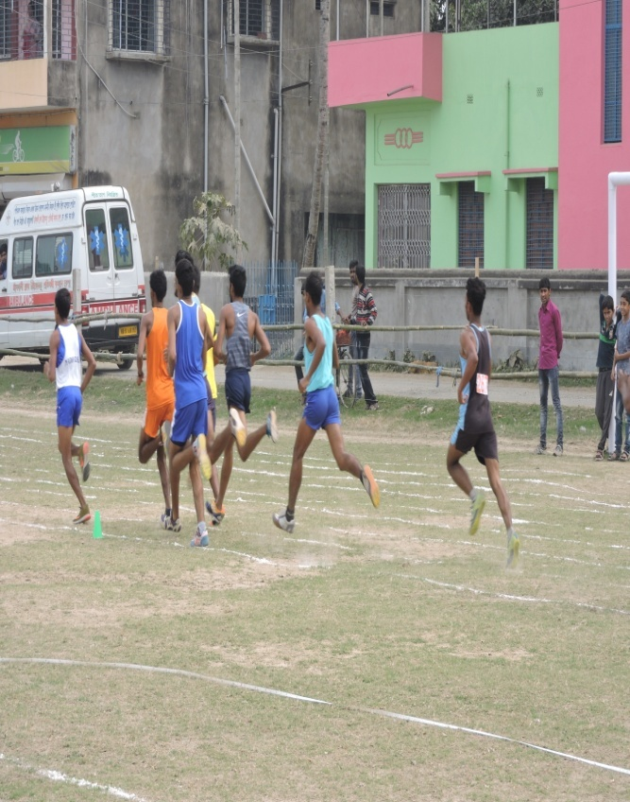 | 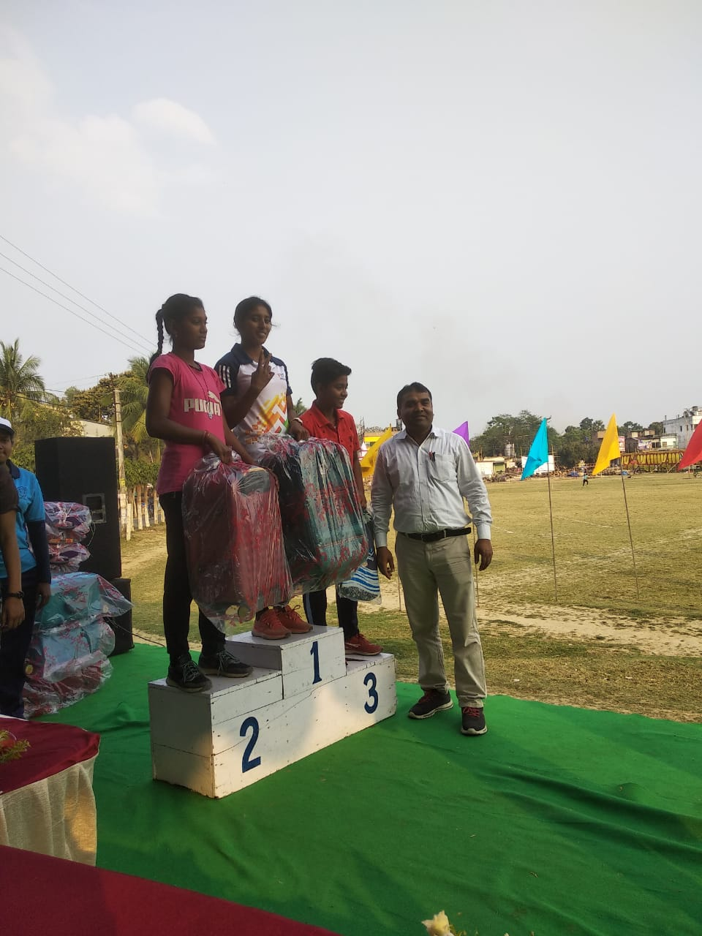

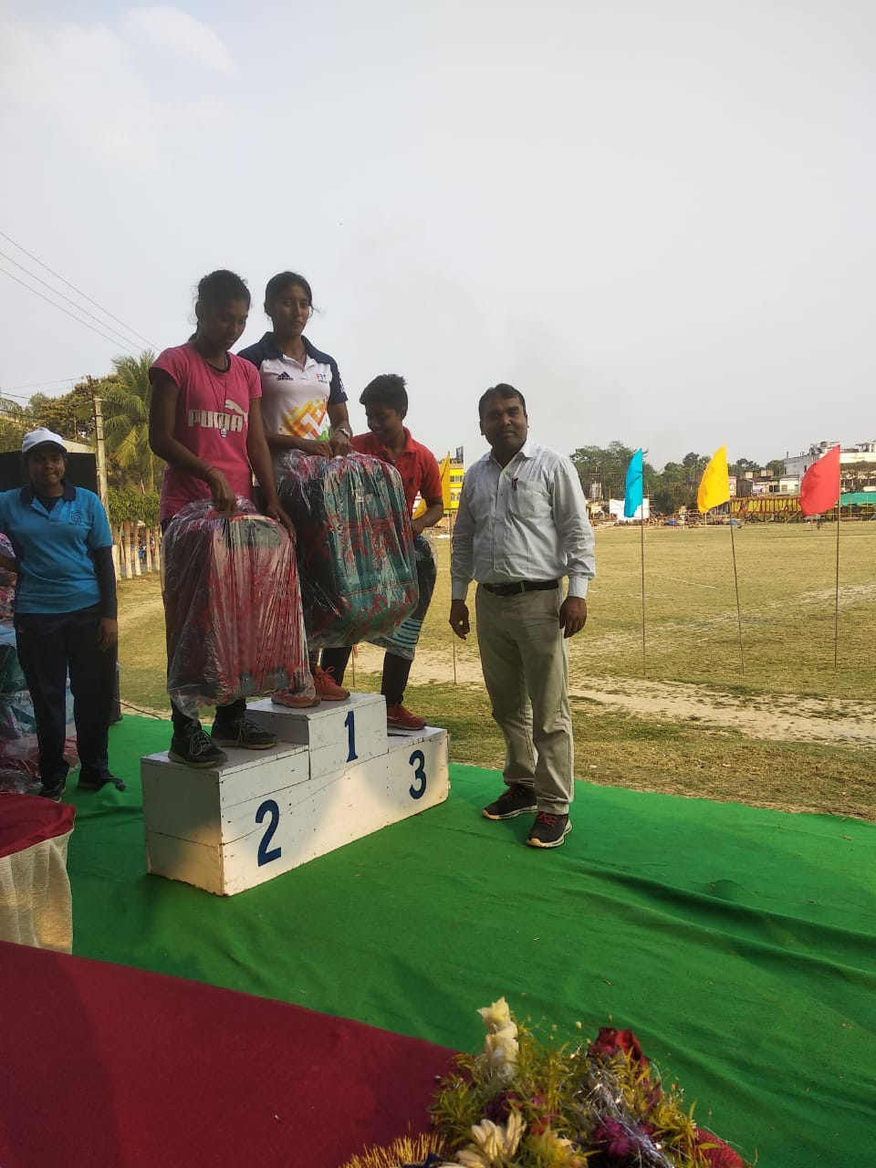 | 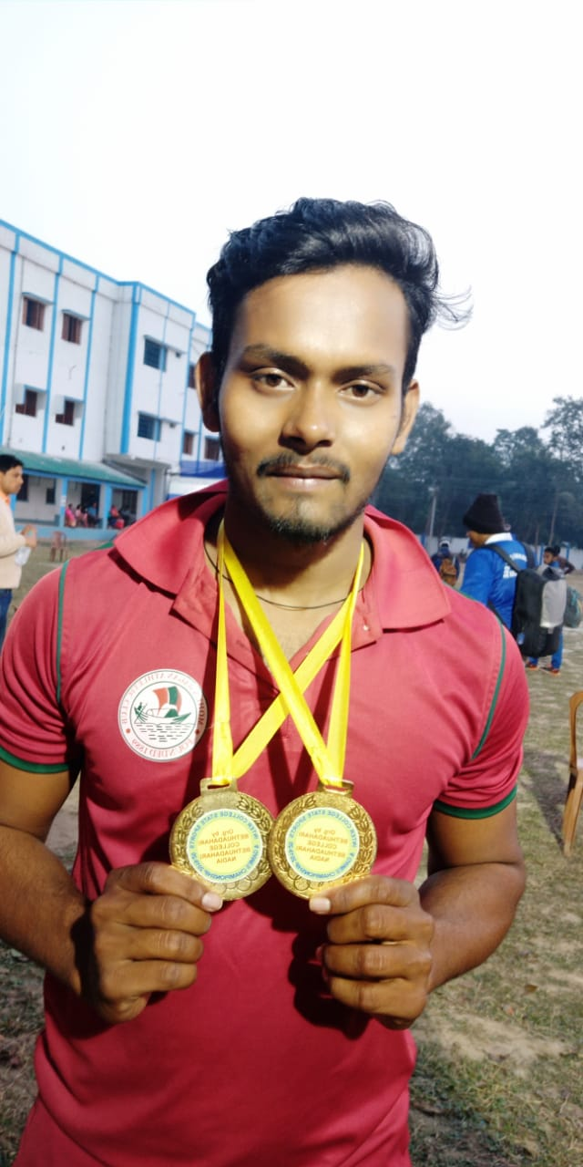

Report Prepared By: Head of the Department
(Physical Education)

